**CMEDIA ReadMe!**

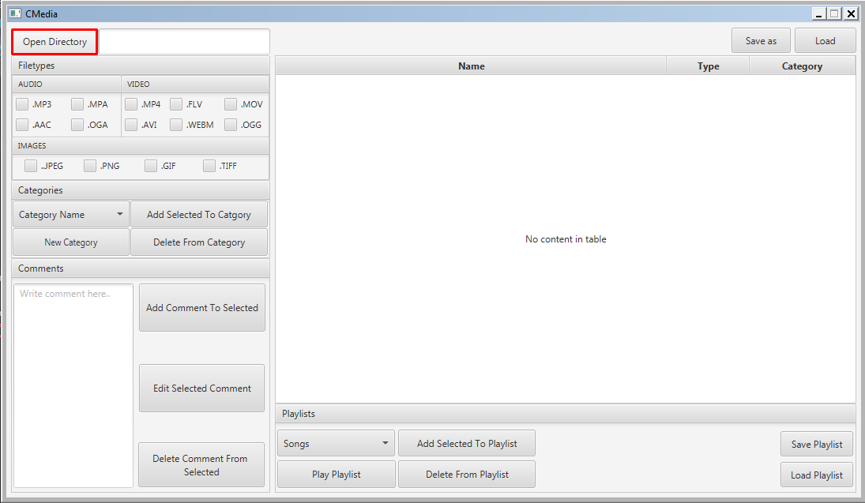

Open Directory – Opens the directory specified by the user.

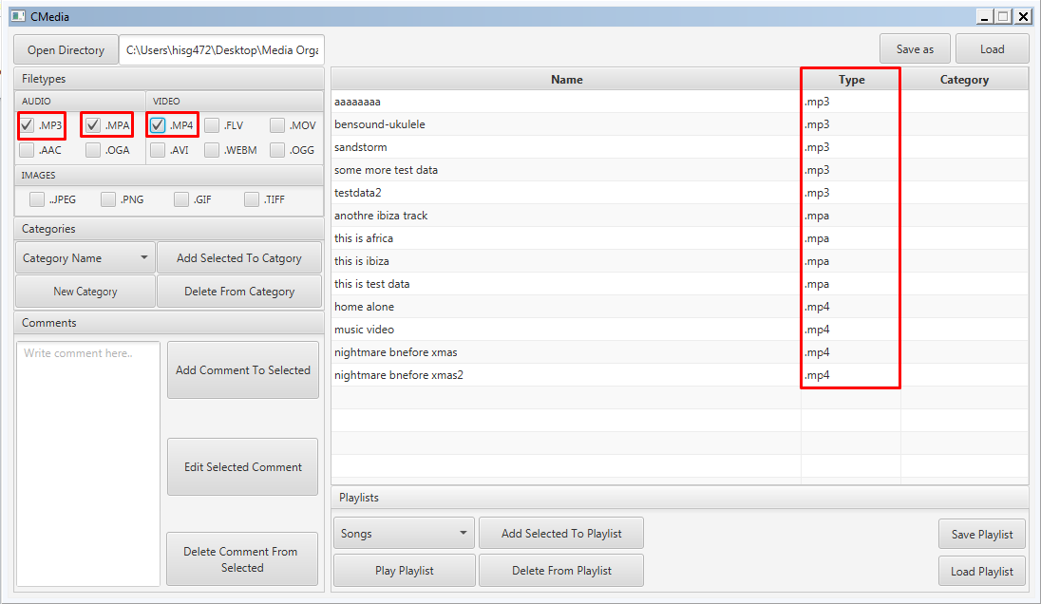

The File types Menu consists of tick boxes that allow the user to filter out file types.

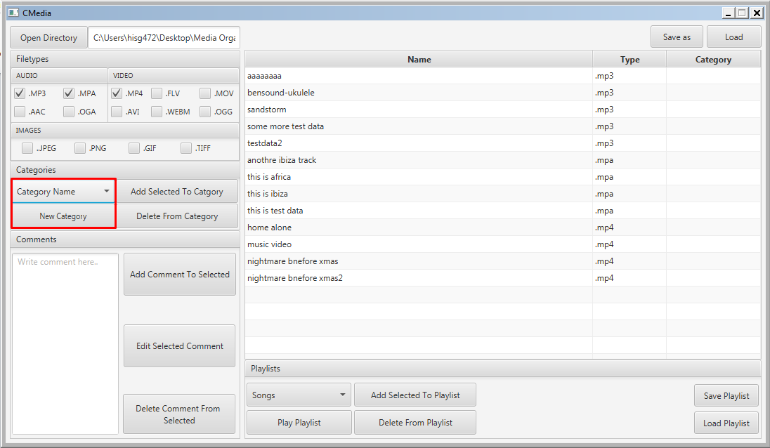

New category corresponds to the dropdown menu “Category name” above and allows the users to define a new category.

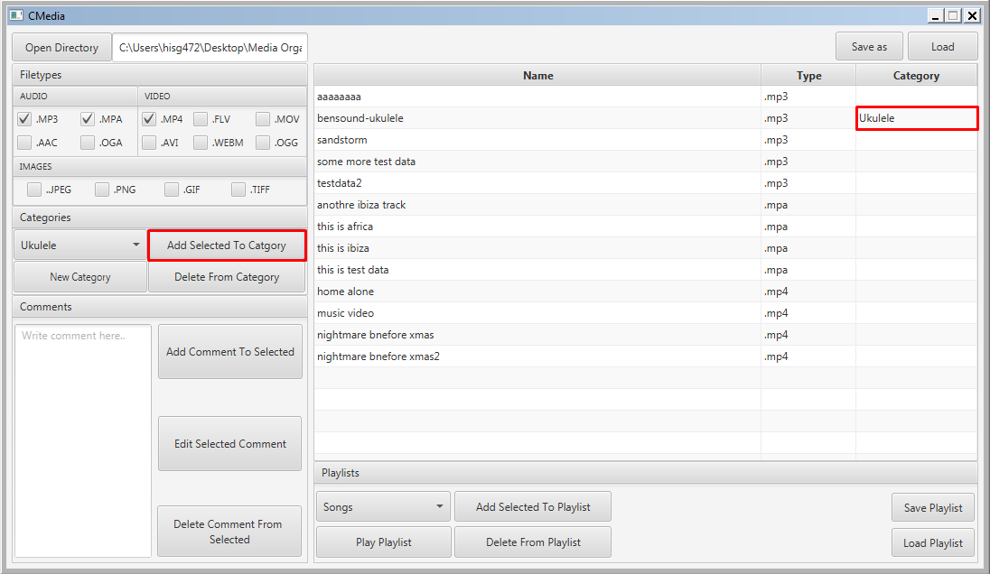

Add Selected To Category adds the current category displayed in the category drop down menu to the selected media type, in the case above “bensound-ukulele” was given the category of “Ukulele”

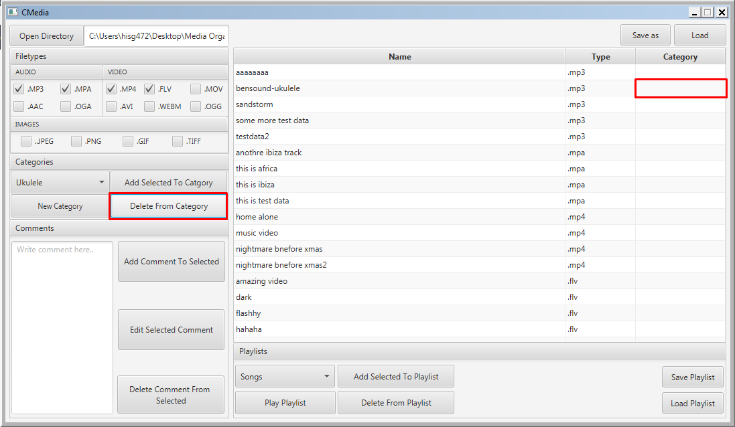

Delete From Category removes the selected category from the selected media, in this case it removes the Category “Ukulele” from “bensound-ukulele”

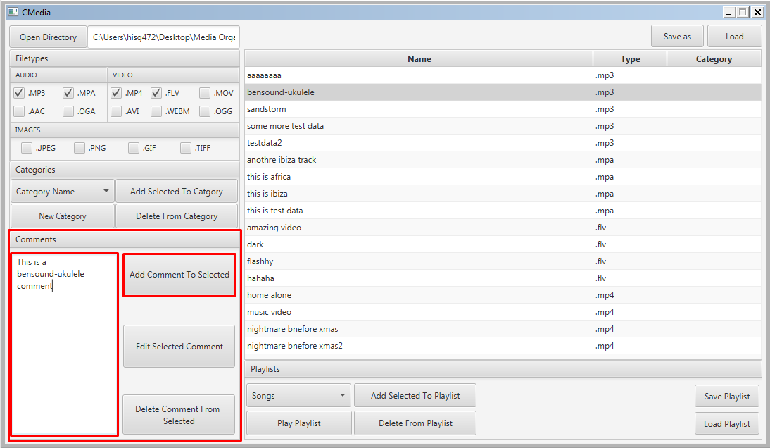

In the comments section, the user can type in the comment box then click “Add Comment To Selected” to add the comment.

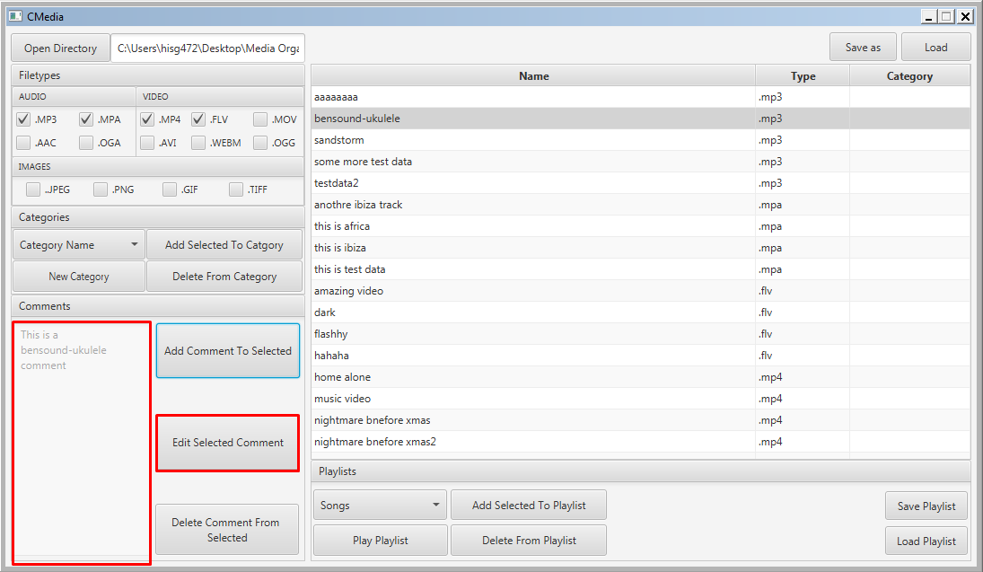

The comment above has been added and greyed out/made non-editable by default to signal a comment already exists.

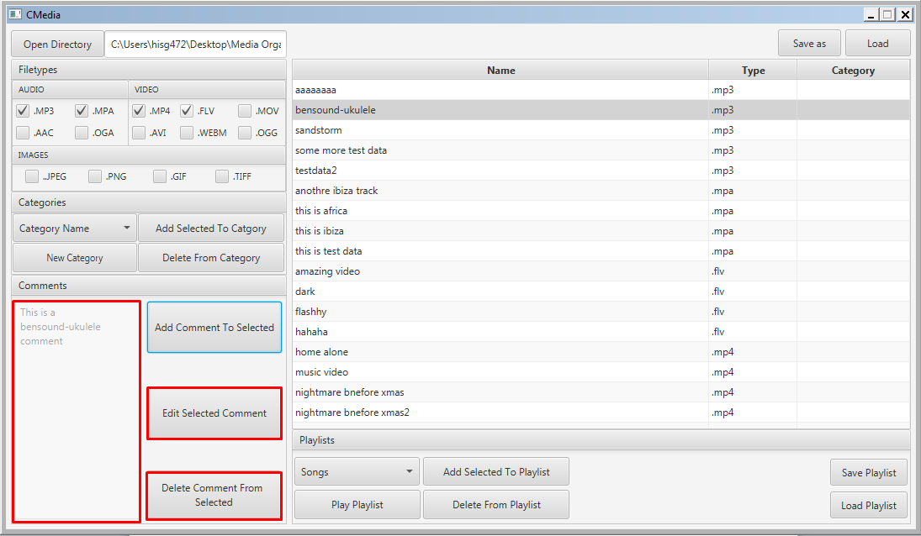

Clicking “Edit Selected Comment” lets the user write in the comment box again if a comment already exists.

Delete Comment From Selected deletes the comment.

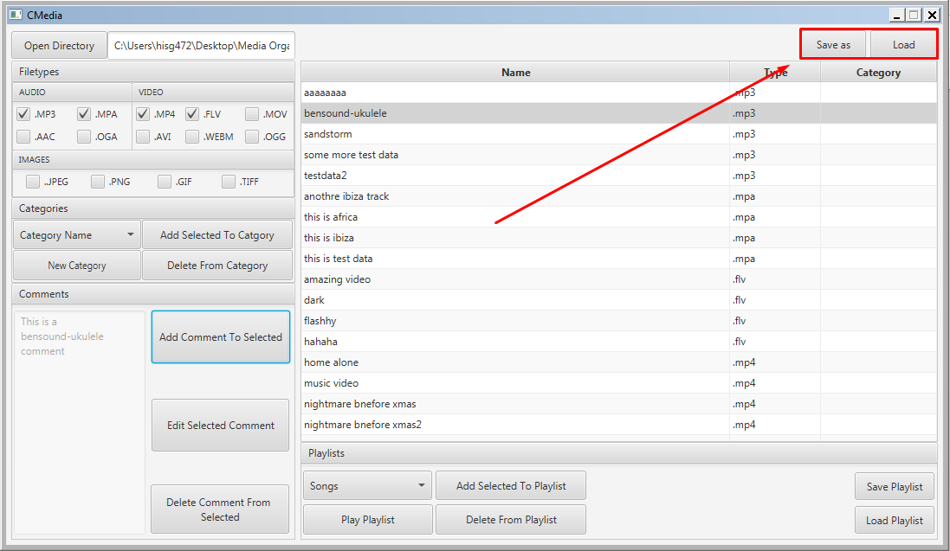

The “Save as” button allows the user to save their work (in xml format) and the “Load button allows the user to read that save.

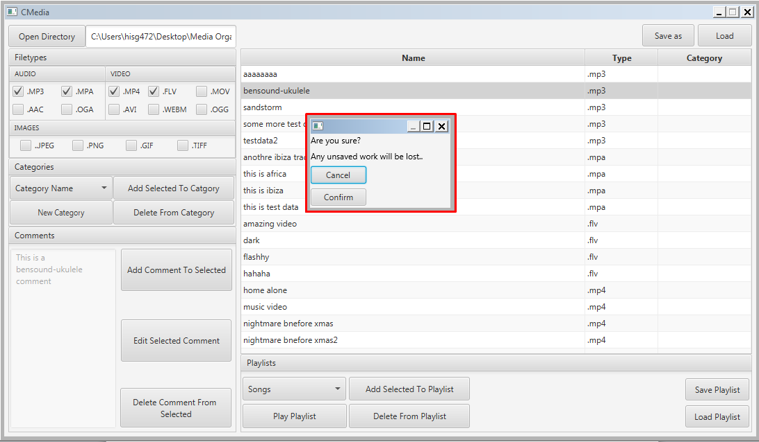

Clicking “Load” or “Open Directory” with an already open directory/map will display this warning message.

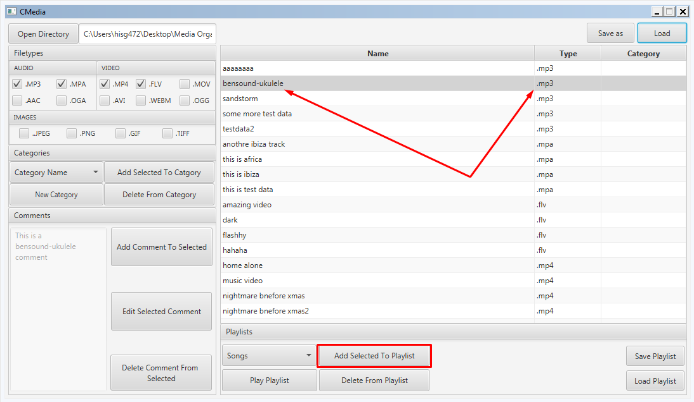

The “Add Selected To Playlist” lets the user add the selected song into a playlist. Only allowed filetypes will be added.

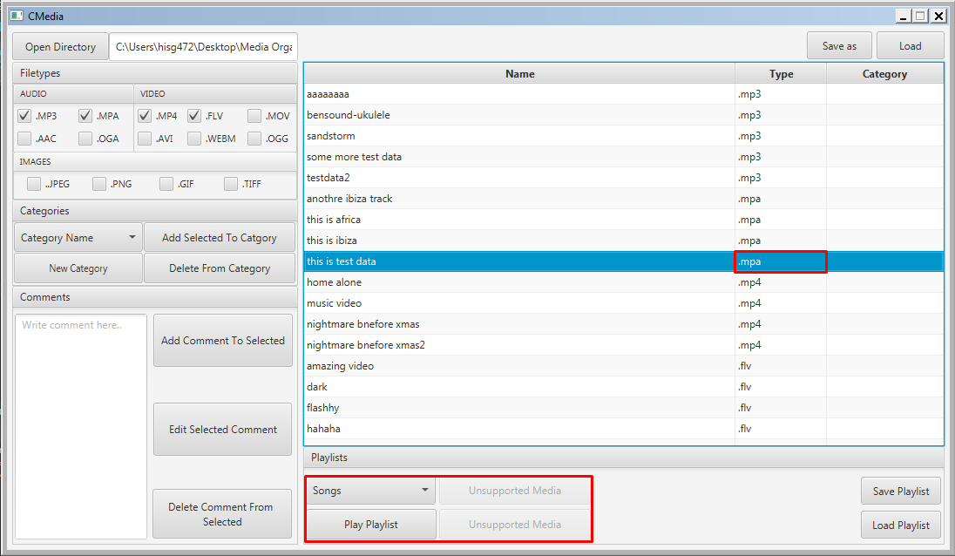

If you highlight an unsupported file type, the buttons are greyed out.

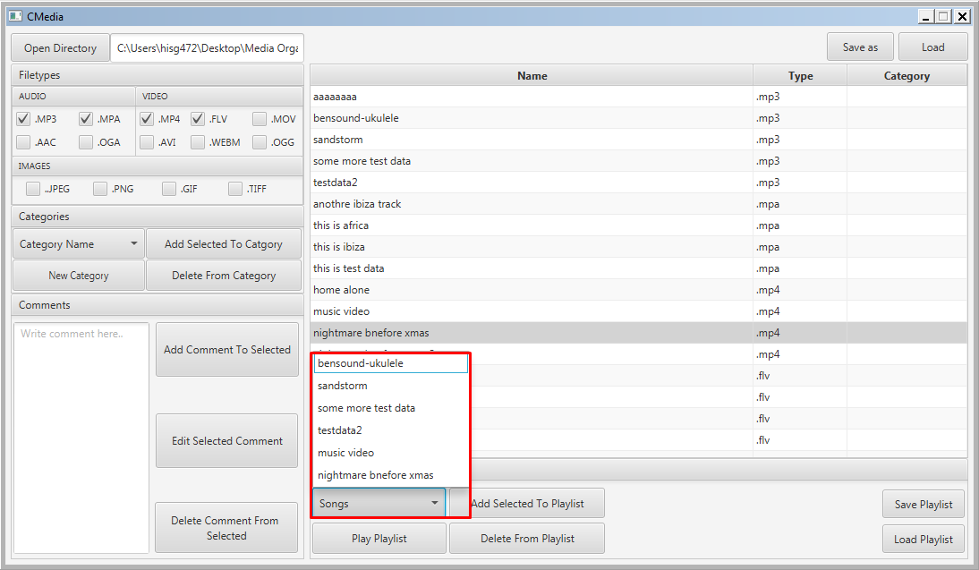

The “Songs” dropdown shows all the current songs in the playlist.

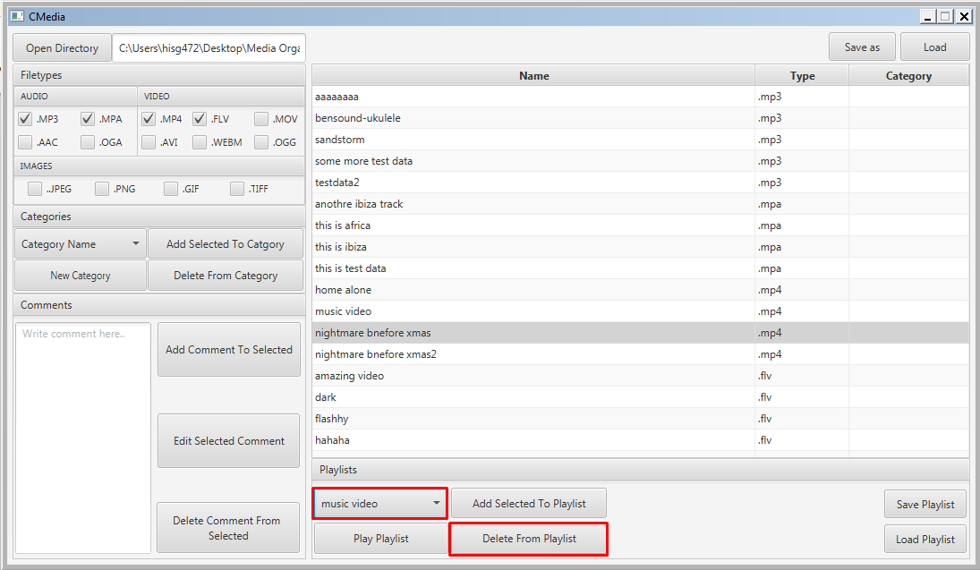

Clicking “Delete From Playlist” Deletes the currently highlighted value in “Songs” dropdown, “music video” is removed in this example.

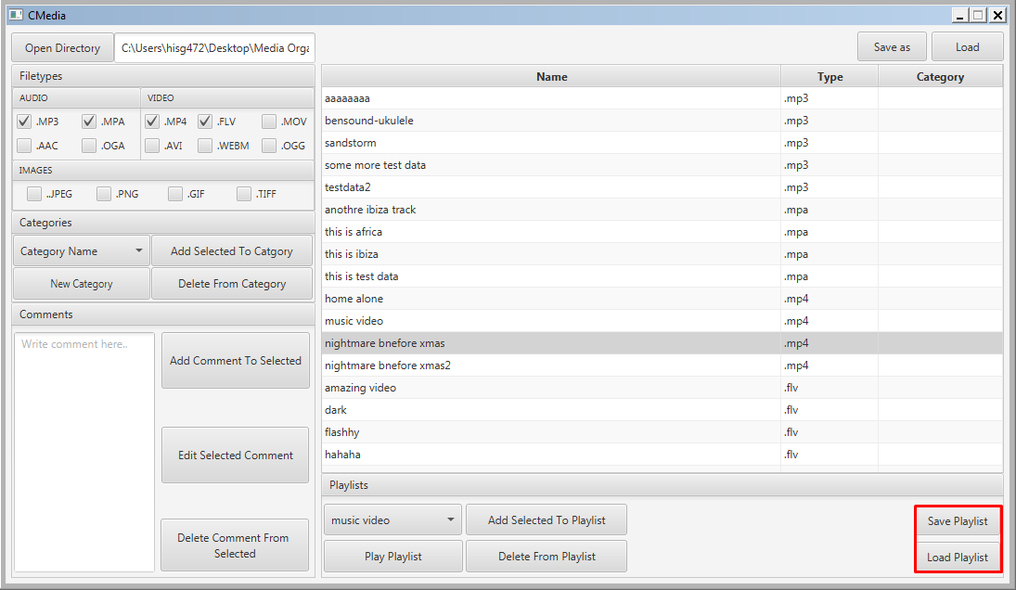

“Save Playlist” and “Load Playlist” let the user save and load the current playlist, separately from the main saves.